**Online Diary**

**Strategic and Twitch skill**

**4.0 Introduction**

This week’s task we had to choose between a strategic game and twitch game. My team overall chose the strategic game. The task we had was to create a game where players would work together to diffuse a bomb against a time limit. We used the concept of “keep talking and nobody explodes” ( <https://keeptalkinggame.com/>) and altered it so it would it would meet the brief. We decided to also make this game a VR game

**4.1 Materials**

2 VR headsets

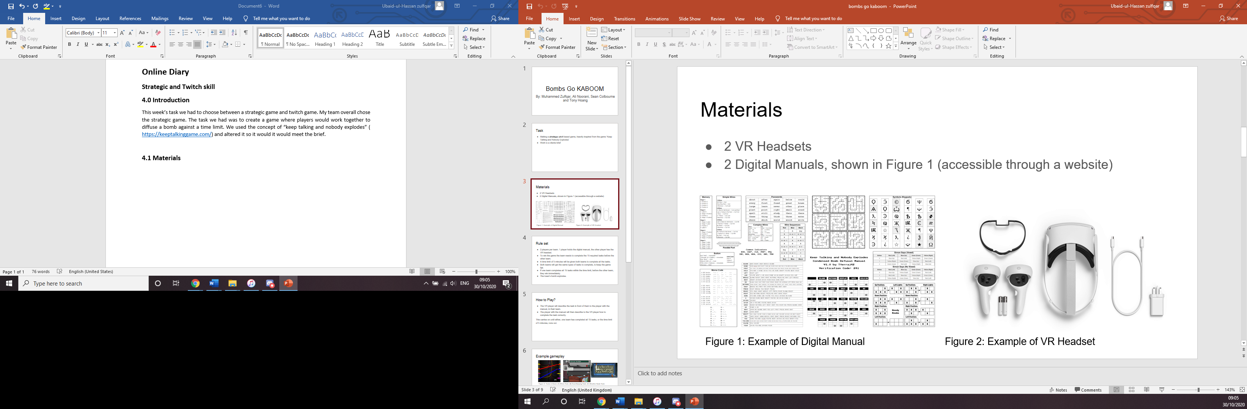

2 digital manuals



**4.2 Rules**

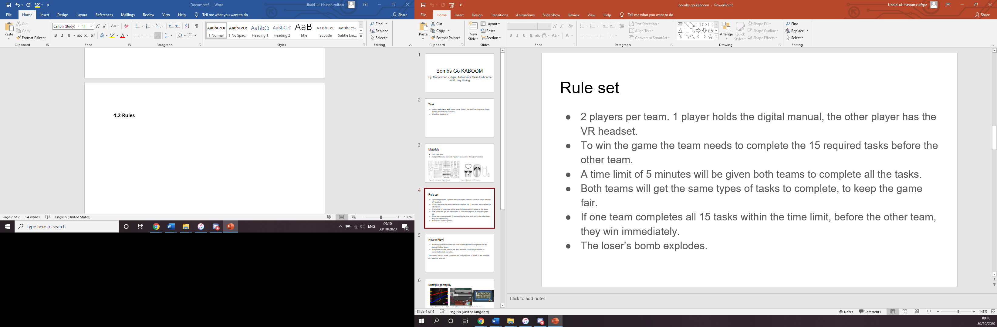

While making the game we had to alter the rules a lot. The reason being because the original idea of the game was for 2 people to finish the task as fast as possible. After someone went of and read the brief again, we realised the brief said it had to be cooperative and against a time limit. We went of altered the game slightly, we still kept the idea of a competitive bomb defusal but made into teams instead of being it being solo. Adding the time limit was easy as all we had to add a 5 minutes time limit for both teams. This meant that both teams had 5 minutes to complete as many tasks as they could, the team that completed the least would go kaboom hence the name “bombs go kaboom”.

**4.3 Gameplay**

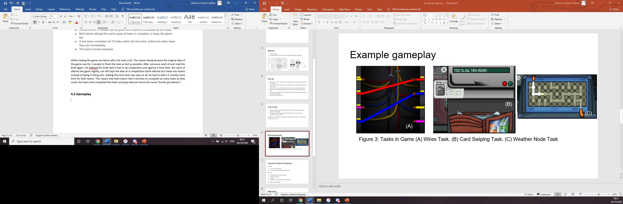

Ideally, we wanted the game to look something like that however we did not have a VR headset to actually make a game with. We overcame that challenge by using people’s imagination. The people reading out the tasks would have to make up tasks and also had to tell the people doing the tasks if they had failed or not. The people who would be doing the tasks pretended to do the tasks as well.

**4.4 Playtesting**

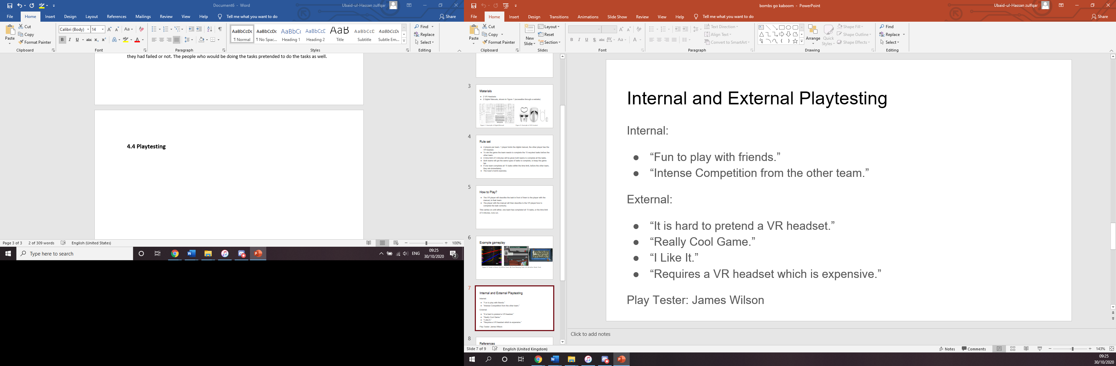

One of the most obvious feedback we got from playtesting was the not having a VR game to actually play. That being said people still liked playing the game. The play tester said the game was fun however if the game was actually made it would be expensive, these were good points but at that stage we couldn’t modify the actual game to be a non-VR game.

**4.5 Reflection**

Making this game was fun. I enjoyed working with my team to actually make this game. That being said I don’t think I will be using VR in future games as we do not have the resources., however it was nice to do something that I would normally not think about doing. I also liked being able to overcome the challenge of not using VR for a VR game. This week has taught me that that there is a lot for me to learn still and that not to shy away from challenges as that makes the experience worth and it makes doing tasks more exciting to do as no one knows the outcome.

